1. Project build was successful and the Twilio Video app was installed on the Simulator device

2. Entered user name and passcode generated from the Function code in CLI and Room Instance “iOS test” **RM6dcd7f210506e1ff0bd1fa223ff7c177**  
  
3. Joined the Room on simulator iOS device

4. Room has been initiated, the participant has joined. No video feed (due to Simulator camera restriction/not available).  
  
5. Logged into the same Room via the React app

6. Both participants are present in the same Room now

7. Another view of the participants

Note: I was able to successfully get output on the older release 0.1.15 but faced issues with the new release 0.1.16 which kept running into fatal error issues.

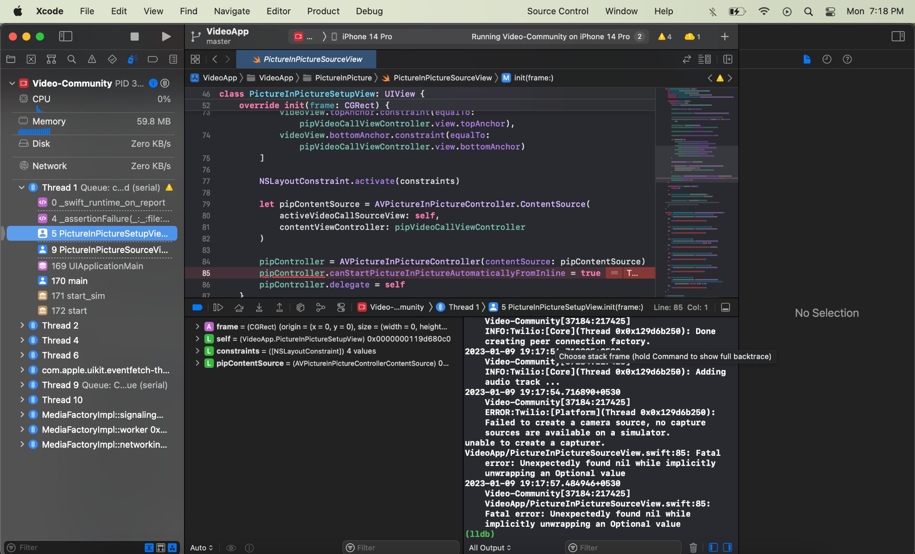

2023-01-09 19:17:42.706906+0530 Video-Community[37184:217425] Unbalanced calls to begin/end appearance transitions for <UINavigationController: 0x11c833000>.

2023-01-09 19:17:54.705827+0530 Video-Community[37184:217425] INFO:twilio:[Core](0x10538c580): Creating peer connection signaling thread ...

2023-01-09 19:17:54.705992+0530 Video-Community[37184:217425] INFO:twilio:[Core](0x10538c580): Creating peer connection worker thread ...

2023-01-09 19:17:54.706134+0530 Video-Community[37184:217425] INFO:twilio:[Core](0x10538c580): Creating peer connection networking thread ...

2023-01-09 19:17:54.706452+0530 Video-Community[37184:217425] INFO:twilio:[Core](0x10538c580): Creating peer connection factory ...

2023-01-09 19:17:54.712873+0530 Video-Community[37184:217425] INFO:twilio:[Core](Thread 0x0x129d6b250): Done creating peer connection factory.

2023-01-09 19:17:54.713325+0530 Video-Community[37184:217425] INFO:twilio:[Core](Thread 0x0x129d6b250): Adding audio track ...

2023-01-09 19:17:54.716890+0530 Video-Community[37184:217425] ERROR:twilio:[Platform](Thread 0x0x129d6b250): Failed to create a camera source, no capture sources are available on a simulator.

unable to create a capturer.

VideoApp/PictureInPictureSourceView.swift:85: Fatal error: Unexpectedly found nil while implicitly unwrapping an Optional value

2023-01-09 19:17:57.484946+0530 Video-Community[37184:217425] VideoApp/PictureInPictureSourceView.swift:85: Fatal error: Unexpectedly found nil while implicitly unwrapping an Optional value

(lldb)